

Online Host, Visualization, and Deployment

**Submitted by**

**Vamsi Draksharam: Class id -9**

**Goutham Gandreddi: Class Id -11**

**Premchand Lingamgunta: Class id - 15**

**Project Goal and objectives:**

**Motivation:**

Abundant models and iterative tests on the models, raised the need for a system to capture and host a model, visualize the results and sharing the trained models online becomes a crucial step of the overall deep learning lifecycle.

**Objective:**

As mentioned above, ‘online host, visualization and deployment’ gives the user a platform where user can upload or download the models or pretty much anything. User can view any model as a separate module and can comment and rate the model.

We are following the MEAN stack approach using Angular as front-end application framework, to create the views for user interaction, Node js and Express to handle the business logic and establish the connectivity to database, for user validations and retrieving the details regarding the models. The Discussion form for each issue is going to have a thread of comments and other features which are planning to be implemented.

**Second increment Report:**

**Architecture Diagrams :**

1. **Class Diagram:**

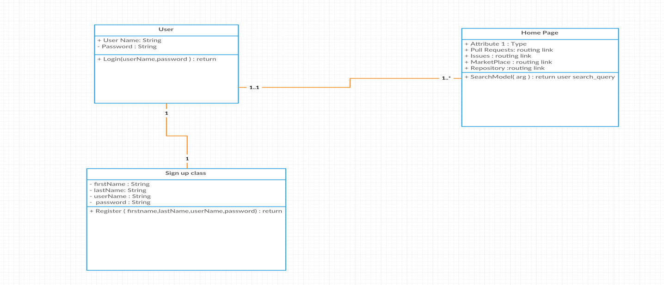

1. **Sequence Diagram:**

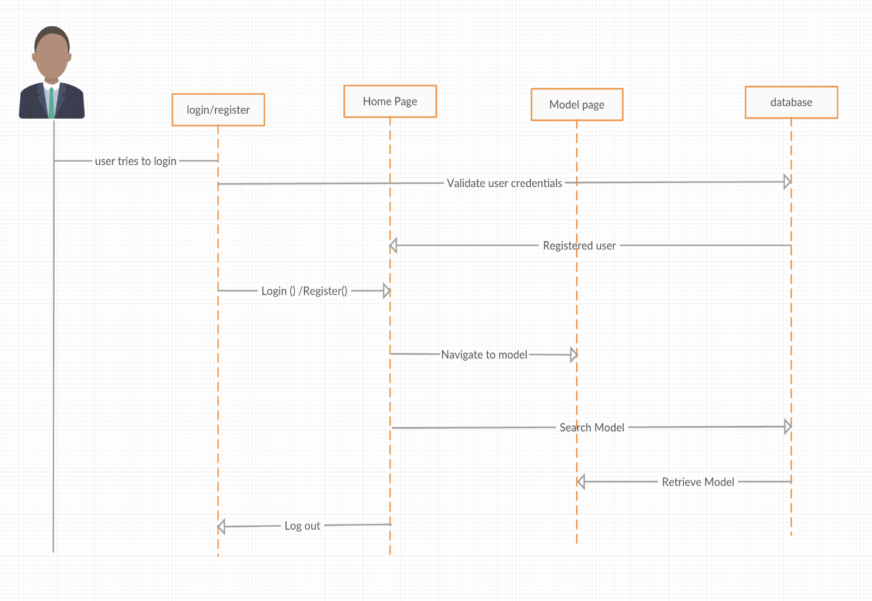

3.Architecture Diagram:

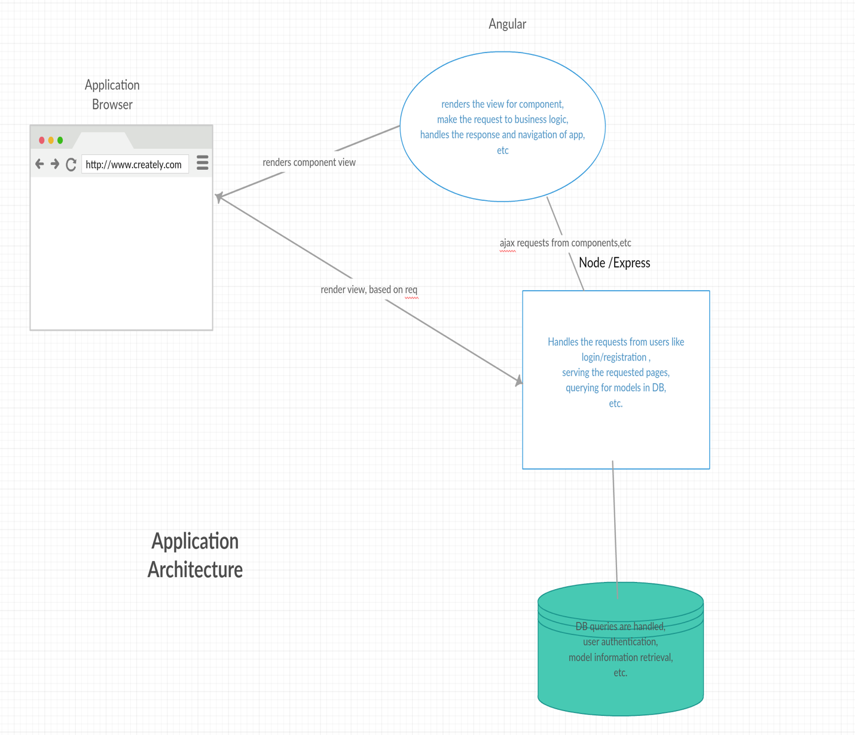

**Third Increment Implementation:**

**Upload files for a repository:**

* Included uploaded feature to add files for the repository and they can be viewed.
* Added like feature to the models.

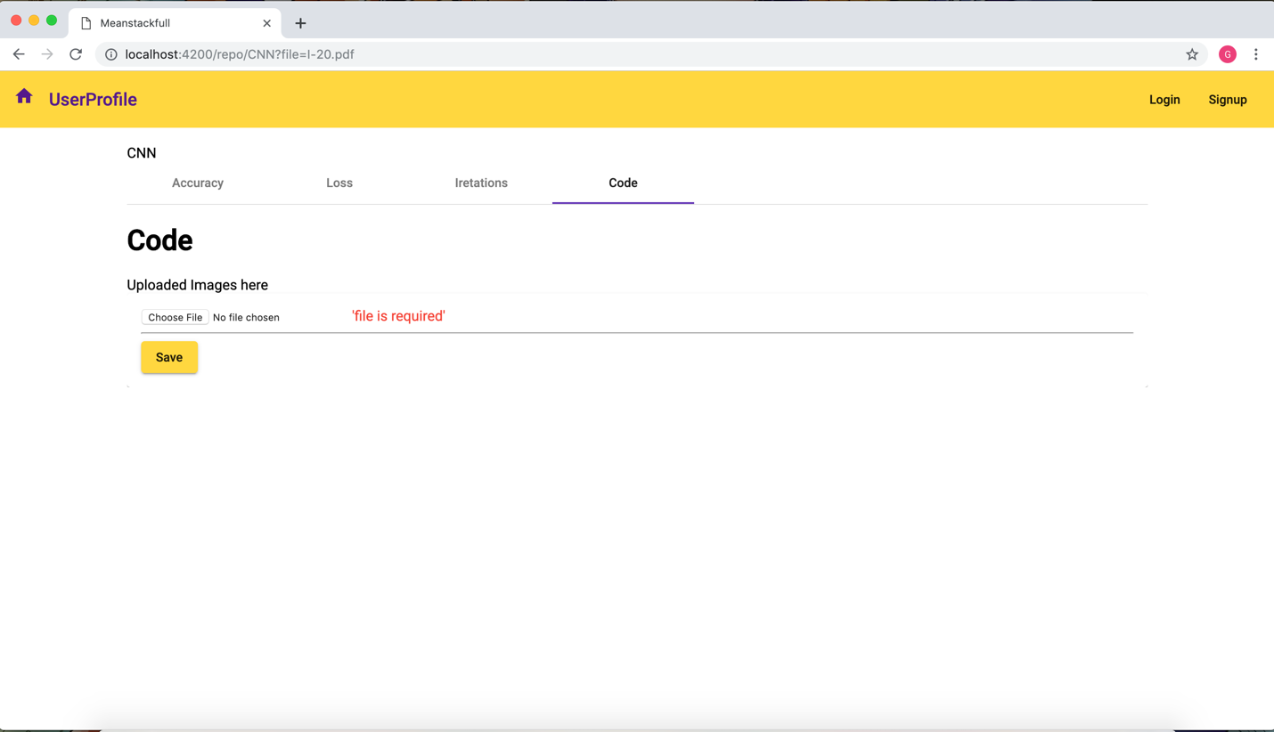

**Fixed Registration Page:**

* After registering the details are not properly entering into the database, we have now handled it and sending it properly to the database and inserting it.
* After registration is successful, the user is now properly redirecting to the Home page user details are visible in user profile.

**Home Page implementation:**

Now the home page will have a search feature in home page and has the currently logged in user details. It has features like logout and creating new repository and also has link to user profile.

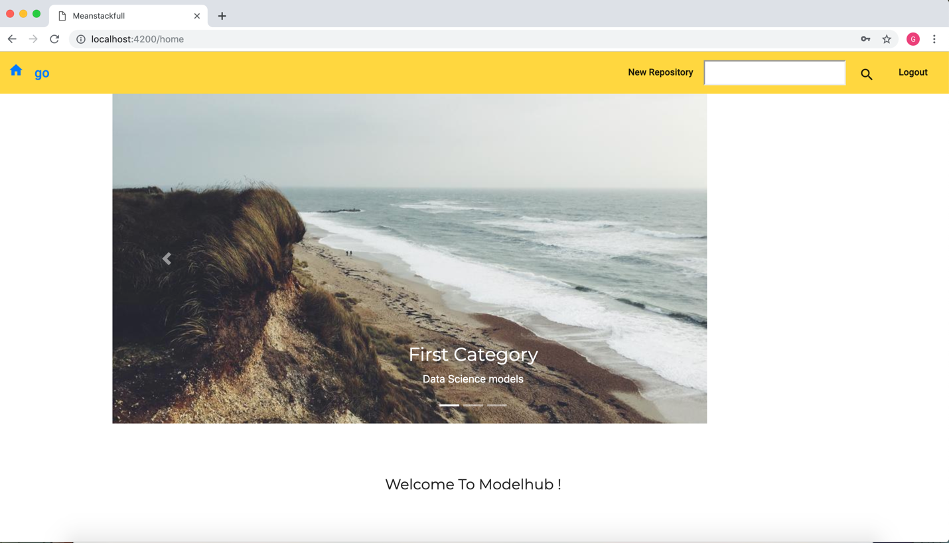

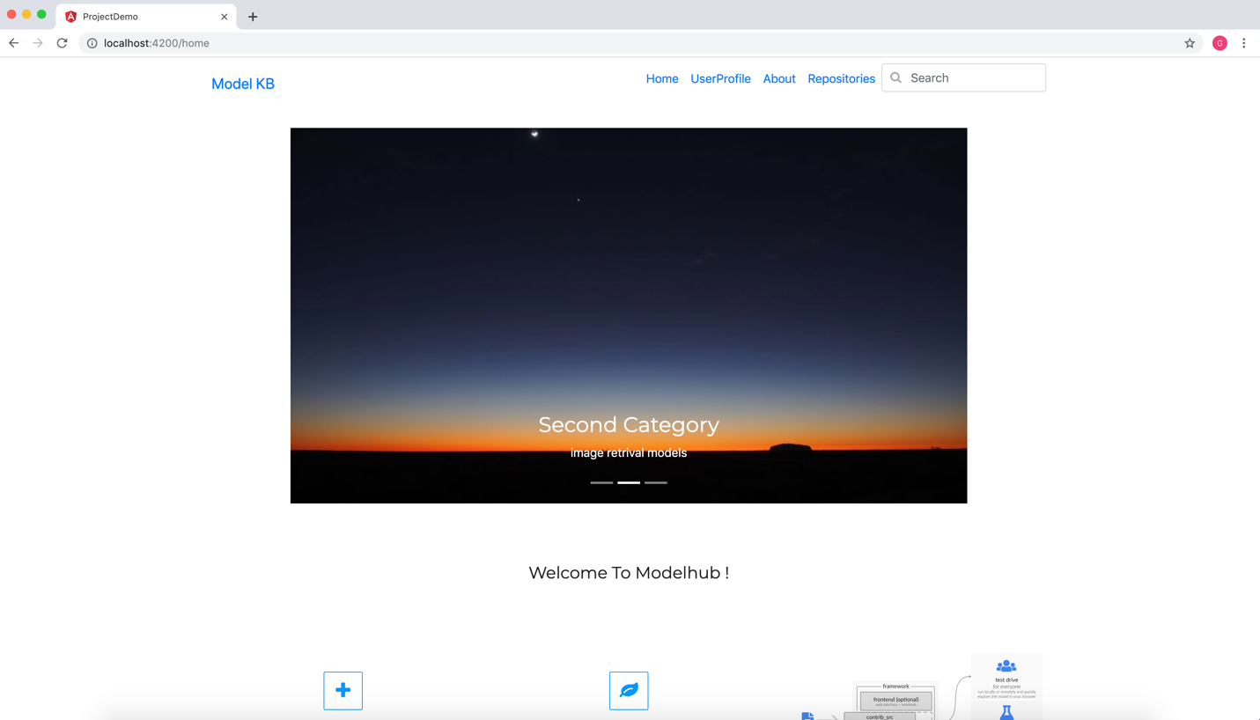

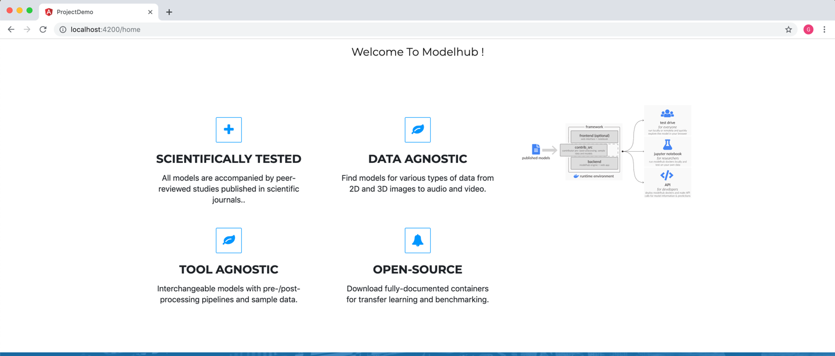

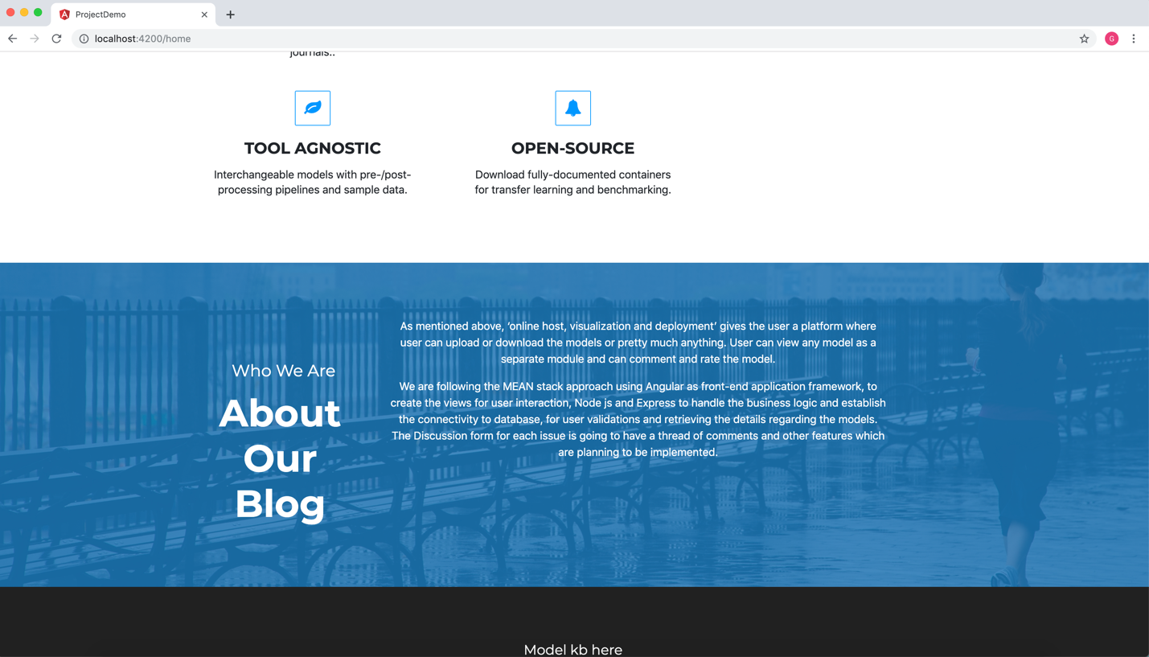

**User Profile:**

* This page gets the user details from the database and displays based on the user login credentials.
* Also we have given features to logout from the application.
* In this increment we have included the repositories in the user profile.

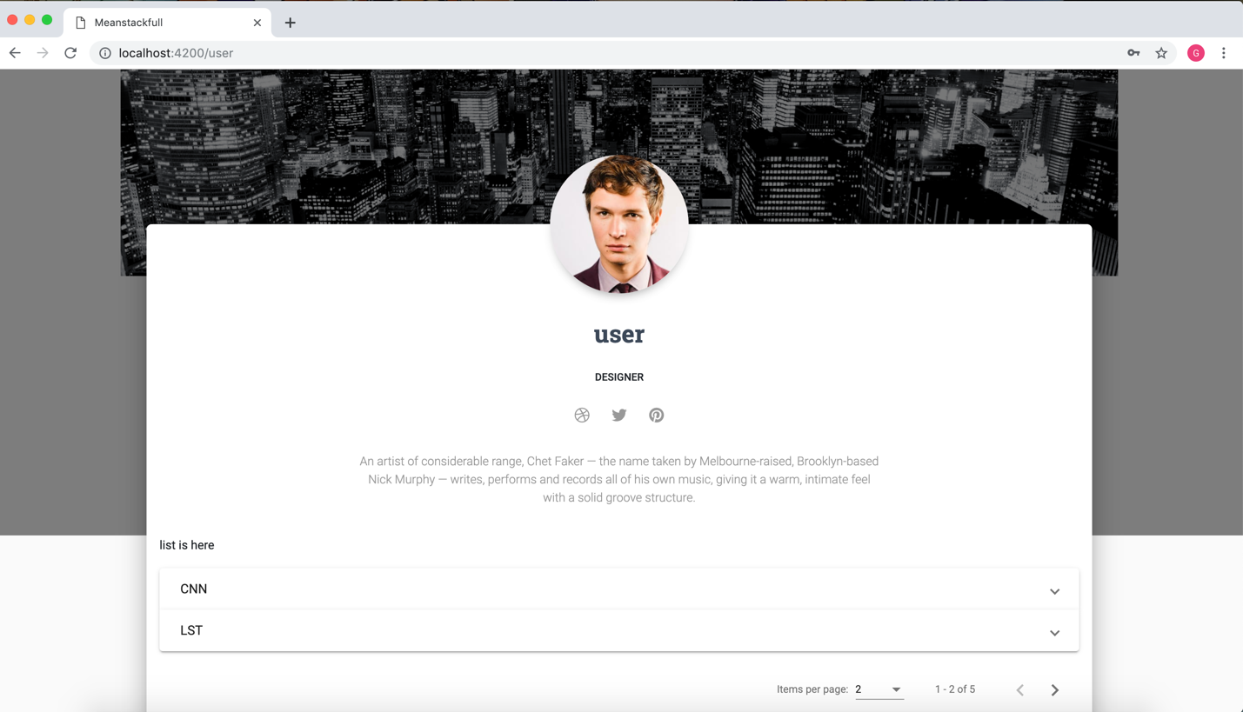

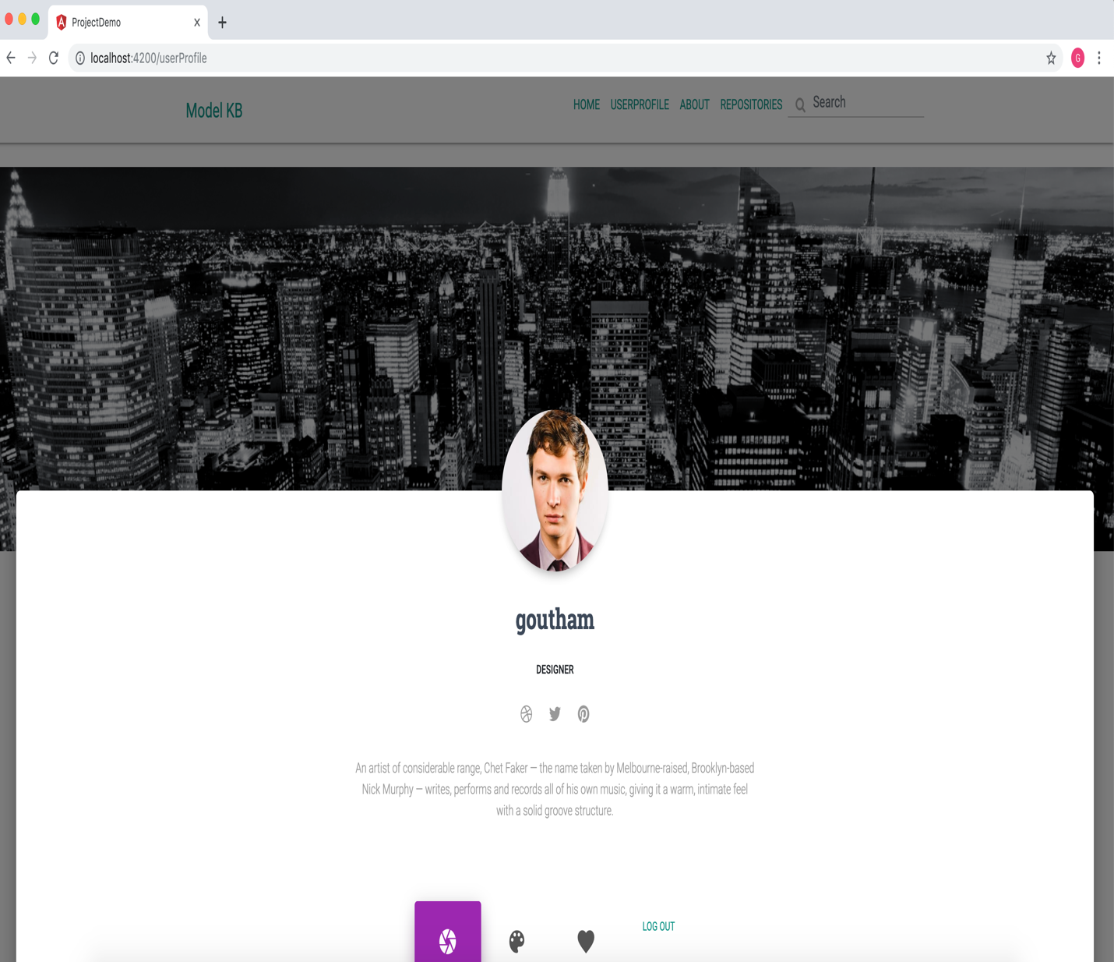

**Like Button for Models**

* This feature has the ability to like or dislike the particular model
* When user clicks on like button the details will be stored in backend
* And fetch response to front-end.

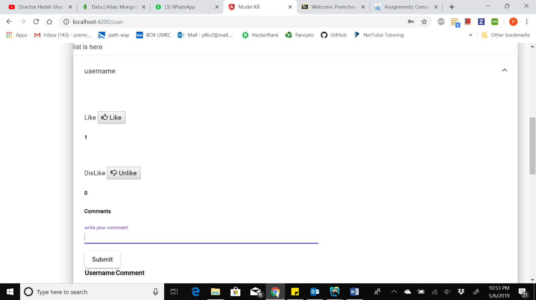

**Comments Section:**

* This feature enables us to write comments for particular Model.
* When we write the comment and press submit the details will bestored at backend and get back with response**.**

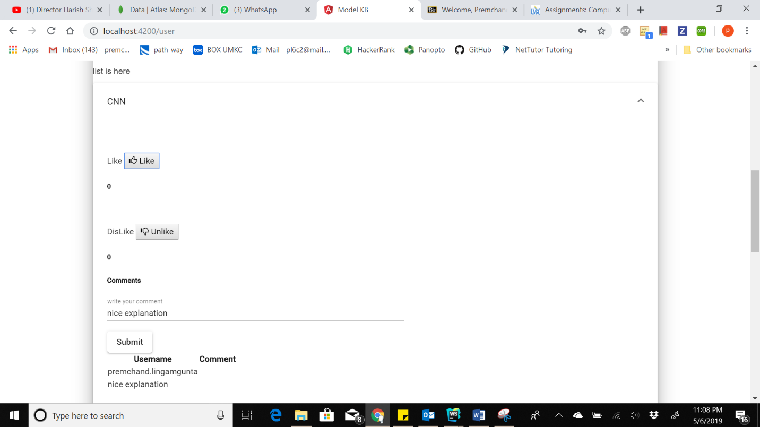

**Search for Model:**

* This feature enables us to search for a particular model which we have already. If we don’t have searched model it will display nothing.
* Here we have entered CNN model name and we got 2 models of CNN.
* If we click on mat-icon we redirected to visualization of that model**.**

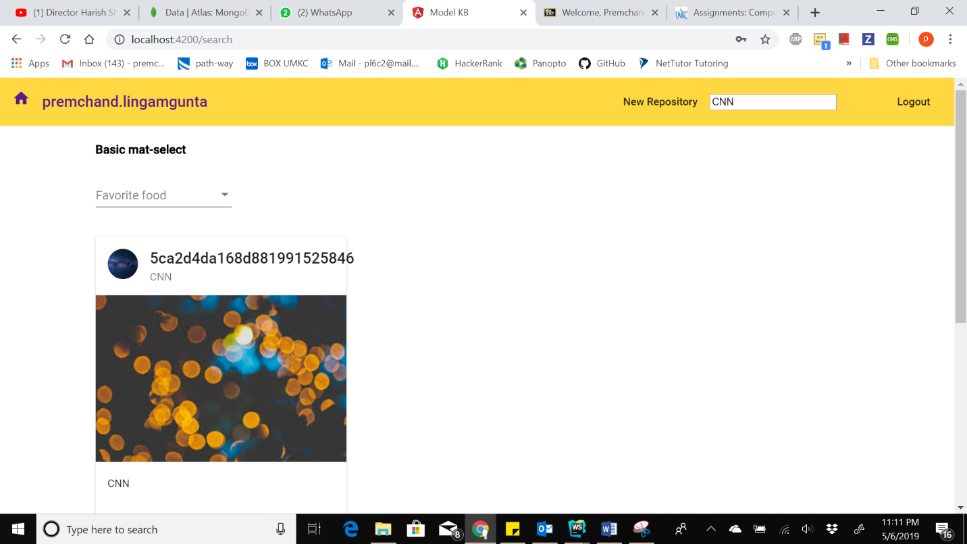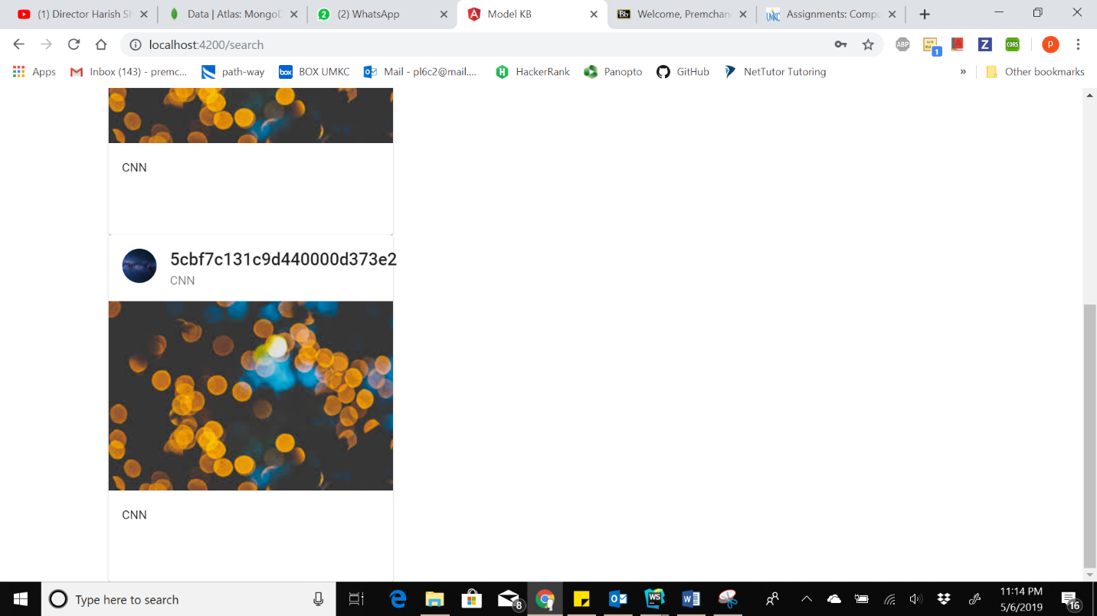

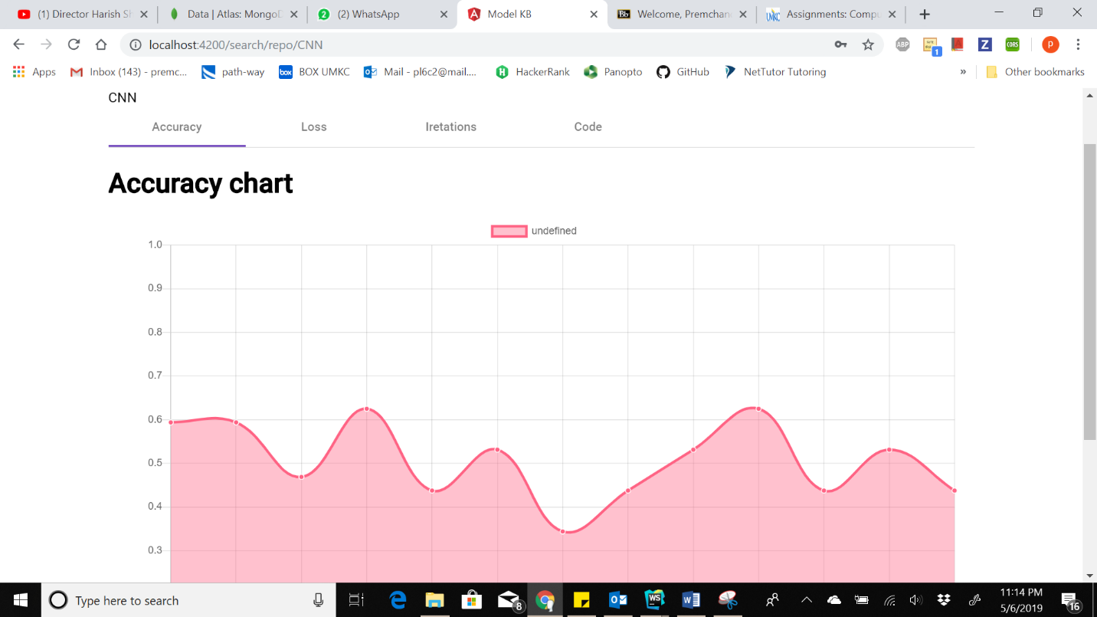

**Filter Feature:**

* This feature enables us to filter through the models which we have already in db.
* When we select our required model we will get back our results as shown
* Here we choose deep learning as our filter. So it will display models regarding our filter value.

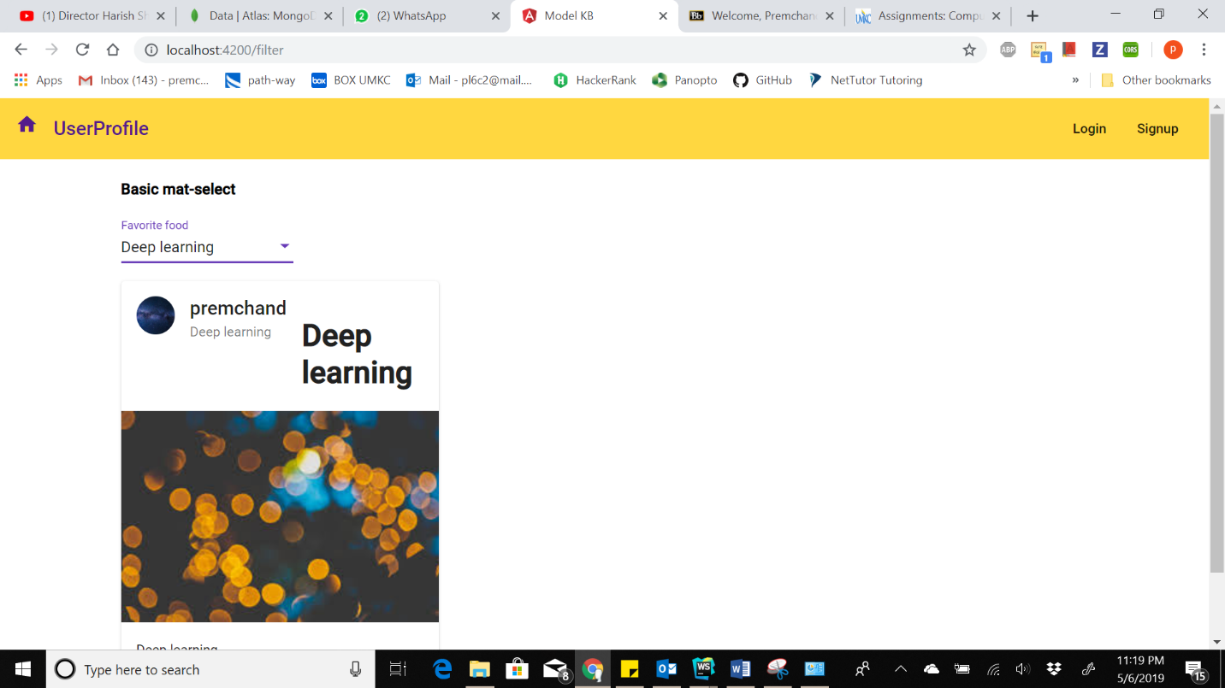

**Project Management:**

**Implementation Status Report:**

**Work Completed:**

**Home Page implementation: –**

**Responsibility and Time Taken:**

* Premchand Lingamgunta – Design and Implementation of the registration page (5 days)
* Vamsi Draksharam – (5 days)
* Goutham Gandreddi – User details and editing features only when login is success (5 days)

**User Profile:**

**Responsibility and Time Taken:**

* Vamsi Draksharam – user info (3 days)
* Goutham Gandreddi – included repositories or models (5 days)

**Repositories:**

**Responsibility and Time Taken:**

* Goutham Gandreddi- Implemented the login page (4 days)
* Premchand Lingamgunta – implemented like feature (4 days)
* Premchand Lingamgunta - Searching files (4 days)

**Uploading Files:**

**Responsibility and Time Taken:**

* Goutham Gandreddi- Implemented uploading files(4 days)

**Searching and Filters:**

**Responsibility and Time Taken:**

* Goutham Gandreddi – Implementing the seach (2 days)
* Premchand Lingamgunta - Implementing the seach (2 days)
* Premchand Lingamgunta - Implementing the Filters (2 days)

**Backend Data Creation and manipulation:**

**Responsibility and Time Taken:**

* Premchand Lingamgunta – Design and Implementation of the registration page (2 days)
* Goutham Gandreddi – (5 days)